
Update date, xx xxxx

Visa Debit Card Fraud Investigation
PROCESS

September 25, 2026

Document Tracking and Control Table

Policy Owner | TBC
Approval Date | TBC
Version | TBC
Access Level | TBC
Policy Author | TBC
Subject Matter Expert(s) | TBC
Last Full Review Date | TBC
Update Date (changes were made but a full review was not necessarily conducted) | TBC
Review Frequency Requirement | TBC
Changes made | TBC
Stakeholders Impacted | TBC

Table of Contents
​
​
​
​
​
1 Purpose 2
2 Scope 2
3 Roles and Systems 2
4 Member-Reported Visa Debit Card Fraud Referral – Process Flow and Procedure 3
4.1 Process Flow 3
4.2 Procedure 3
4.2.1 Review Referral and Available Information 3
4.2.2 Conduct Investigation 4
4.2.3 Determine Investigation Outcome 5
4.2.4 Record Disposition, Reason Code, and Investigation Notes 5
4.2.5 Determine Response Action 6
4.2.6 Inform Growth of Decision 6
4.2.7 Complete Reporting and eDetect Updates 6
5 eDetect Fraud Alert Referral – Process Flow and Procedure 6
6 Visa Debit Card Fraud Types 7
Appendix 7
Version History 7

​

​

​

​

​

Purpose
The Visa Debit Dispute Management Procedure provides the Growth, Payment Services, Fraud Prevention, and Finance teams with guidance for managing member-initiated Visa Debit Card disputes. This procedure establishes a consistent, end-to-end approach for receiving and triaging dispute claims, preparing and assessing supporting documentation, issuing provisional credit, submitting and managing the dispute through Central 1 and the Visa network, and resolving and recovering the dispute outcome.
It also outlines the roles and systems, process flows, and detailed procedures that support the end-to-end dispute management lifecycle, including the applicable handoffs to the Visa Debit Card Fraud Investigation Process and the Visa Debit Card Non-Fraud Investigation Process.

Scope
This procedure applies to Growth, Payment Services, Fraud Prevention, and Finance team members involved in the receipt, triage, investigation, submission, and resolution of member-initiated Visa Debit Card disputes. It is applicable to disputes initiated through the following channel:
- Member-Reported Dispute: occurs when a member contacts the Contact Centre or a Branch to dispute a Visa Debit Card transaction.
This procedure covers the five stages of the dispute management lifecycle: Dispute Intake, Dispute Triage, Case Preparation & Document Assessment, Provisional Credit Issuance, Network Submission & Response, and Resolution & Recovery. Case Preparation & Document Assessment and Provisional Credit Issuance are run in parallel.
Out of scope: within Case Preparation & Document Assessment, once a case is assigned and investigation commences, the Fraud Specialist should refer to the Visa Debit Card Fraud Investigation Process and the Payment Services agent should refer to the Visa Debit Card Non-Fraud Investigation Process for the detailed investigation steps; those investigation activities are out of scope for this procedure. This procedure resumes at the case submission decision point once that investigation is complete.

Roles and Systems
The following roles and systems support various activities within the Visa Debit Dispute Management Procedure.
Role / System | Responsibility
Growth Team | Front-line Contact Centre and Branch staff who receive the member's dispute claim, verify the cardholder and impacted transaction(s), administer the Visa Debit Dispute Questions to determine transaction recognition and authorization, perform initial account security actions (block/reissue) where required, and create and assign the case.
Payment Services Team | Investigates and manages non-fraud (recognized/authorized transactions) disputes referred via the ATM / POS trace, prepares case documentation, submits eligible disputes to Central 1, monitors Acquirer responses and escalations, and manages dispute outcomes and recoveries for non-fraud cases. Refers to the Visa Debit Card Non-Fraud Investigation Process for detailed investigation steps.
Fraud Prevention Team | Investigates and manages fraud (unrecognized/unauthorized transactions) disputes referred via the Fraud Intake Form (FIF), prepares case documentation, submits eligible disputes to Central 1, monitors Acquirer responses and escalations, and manages dispute outcomes and recoveries for fraud cases. Refers to the Visa Debit Card Fraud Investigation Process for detailed investigation steps.
Finance Team | Validates and posts provisional credit to the member's account within Visa SLAs, tracks provisional credit aging and reversal, finalizes or reverses provisional credit based on the dispute outcome, and records recoveries, losses, fees, and general ledger entries.
Central 1 | Beem's financial services partner that receives completed dispute submissions and routes them, via PPJV, to the FIS Everlink Settlement team for submission to Visa Resolve Online (VROL) on Beem's behalf.
FIS Everlink (Everlink) | Beem's Visa Debit program processor. Submits chargeback and dispute requests to Visa on Beem's behalf via VROL, and manages the pre-arbitration and arbitration cycle in accordance with Visa Rules and Everlink's internal processing deadlines.
Visa | The payment network. Sets dispute rules, reason codes, filing windows, and timeframes, and routes dispute messages and funds between the Issuer (Beem) and the Acquirer.
CRM (Dynamics 365) | System of record used to complete the Fraud Intake Form (FIF), create and track dispute cases, and log case status updates and investigation notes.
DNA | Beem's core banking system used to review member and account information, apply card or account restrictions, and process provisional credit, reversal, and general ledger postings.
Existing POS / ATM Trace Form | Existing trace request form used by Payment Services to initiate a non-fraud (recognized transaction) dispute, which is submitted to Central 1 for onward routing to Everlink.
Visa Resolve Online (VROL) | Visa's online dispute filing system, accessed by Everlink on Beem's behalf, used to submit disputes and manage the pre-arbitration and arbitration cycle.

Stage 1: Dispute Intake (Growth)

4.1 Process Flow
The visual overview below provides the end-to-end process for a member contacting the Contact Centre or a Branch to initiate a Visa Debit Card dispute. This stage is owned by Growth.
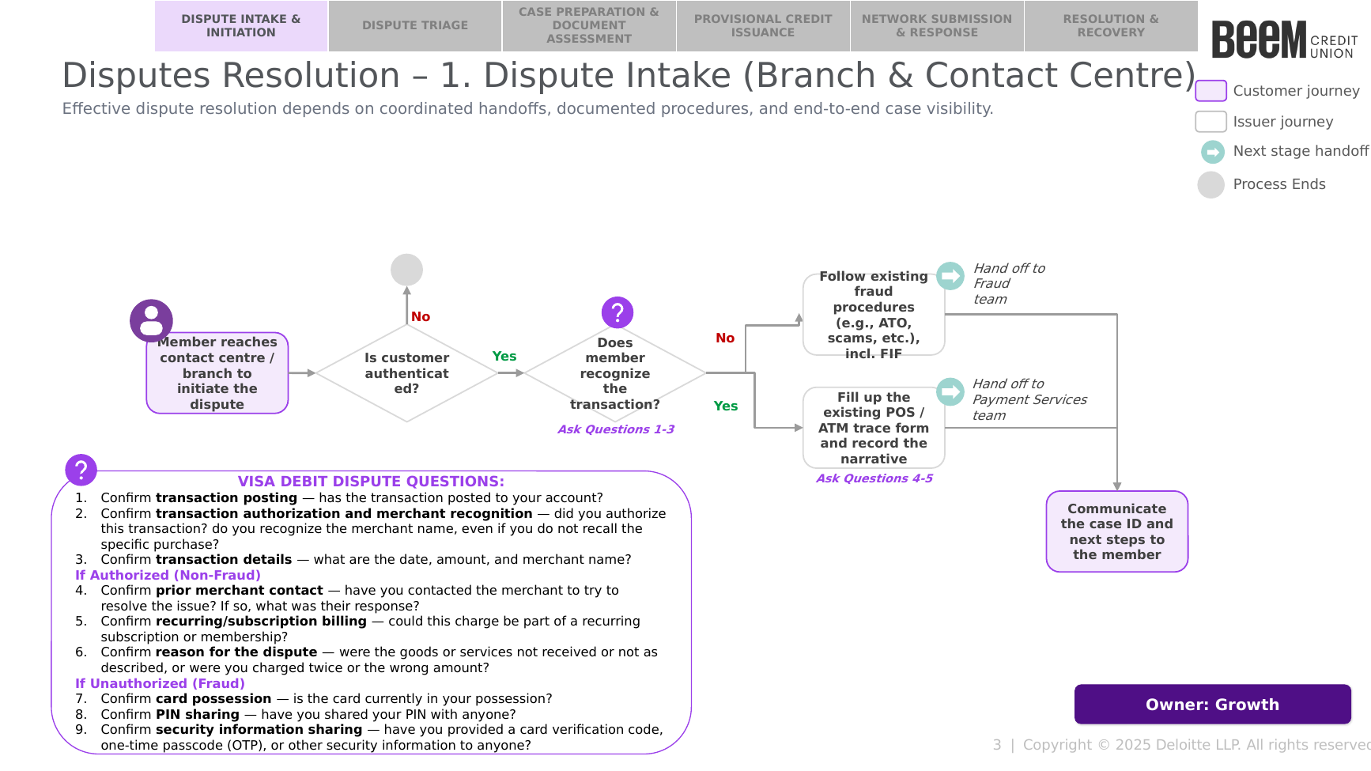

4.2 Procedure
The following procedure provides a step-by-step outline of the activities performed by Growth as part of dispute intake.

4.2.1 Receive and Verify the Member
Upon a member contacting the Contact Centre or a Branch to dispute a Visa Debit Card transaction, the Growth Team member should:
- Receive the member's dispute claim via the Contact Centre or Branch.
- Verify the cardholder's identity and confirm the member is authenticated, per Beem's existing member authentication procedures [TBC — reference to be confirmed]. If the member cannot be authenticated, do not proceed with intake.

4.2.2 Confirm Transaction Posting and Locate the Transaction
The Growth Team member should:
- Confirm transaction posting — has the transaction posted to the member's account?
  - If not yet posted: advise the member to wait until the transaction posts before a dispute can be initiated.
  - If posted: proceed to Step 2.
- Locate the transaction the member is disputing in DNA [TBC — system to be confirmed], using the date, amount, and merchant name provided by the member.
  - If located: proceed to Section 4.2.3 — Create the CRM Case.
  - If it cannot be located: ask the member to reconfirm the date, amount, and merchant name, and search again. If the transaction still cannot be located, inform the member that Beem has no record of this transaction and a dispute cannot be initiated at this time. This procedure ends.

4.2.3 Create the CRM Case
Open a new CRM Case and populate the following:
- Case Details (auto-populated): unique case ID, case creation date, intake agent, current status, and owner.
- Member Details: member full name (select from dropdown), member email (manually entered), member phone number (manually entered).
- Transaction Details (manually entered based on the DNA transaction located in Section 4.2.2): date, merchant, amount, and type (POS, ATM, or Card-Not-Present).
- Dispute Narrative — using the open-text Dispute Narrative field, record notes on what the member is disputing. Based on what the member shares, also determine whether the transaction is recognized or unrecognized, in order to route the case to the correct team. The questions below are guidance only — not every question needs to be asked in every case; use judgment based on what the member shares.
  - Step 1 — Determine recognition: ask the member the guidance questions below as needed to determine recognition. If the first question already gives a clear answer, the second question may not be necessary:
    - Ask: “Did you authorize this transaction? Do you recognize the merchant name, even if you don’t recall the specific purchase?”
    - Example answer: “No, I’ve never heard of this merchant.” — What it means: this indicates Fraud.
    - Example answer: “Yes, I recognize the merchant and I made that transaction.” — What it means: this indicates Non-Fraud.
    - If needed, ask: “Could this charge be part of a recurring subscription or membership you may have forgotten about?”
    - Example answer: “Oh, I think I signed up for a trial a few months ago.” — What it means: this indicates Non-Fraud (a forgotten subscription).
    - Example answer: “No, I don’t have any subscriptions with this merchant.” — What it means: this indicates Fraud (likely an unauthorized transaction).
  - Step 2 — Capture the reason for the dispute: ask the member:
    - Ask: “Were the goods or services not received or not as described, or were you charged twice or the wrong amount?”
  - Step 3 — Ask one additional context question, based on the Fraud/Non-Fraud determination from Step 1:
    - If Step 1 indicated Fraud, ask: “Is the card currently in your possession? Have you shared your PIN with anyone?”
    - If Step 1 indicated Non-Fraud, ask: “Have you contacted the merchant to try to resolve the issue? If so, what was their response?”

4.2.4 Determine Fraud or Non-Fraud and Route the Case
Based on the member's responses captured in the Dispute Narrative, the Growth Team member selects in the CRM whether the member recognizes the transaction. The CRM then automatically surfaces the applicable form within the case:
- Non-Fraud: the ATM/POS Trace Request form appears. Proceed to Section 4.2.5 — ATM/POS Trace Request (Non-Fraud).
- Fraud: the Fraud Intake Form appears. Proceed to Section 4.2.6 — Fraud Intake Form (Fraud).

4.2.5 ATM/POS Trace Request (Non-Fraud)
The Growth team member should then populate the remaining ATM/POS Trace Request fields within the case, including a note with the following details to help with the Payment Services team investigation:
- Date/time of conversation with the member
- Method of instruction
- The network the transaction occurred on (found within DNA [TBC])
- Any other relevant details the member provided

4.2.6 Fraud Intake Form (Fraud)
The Growth Team member should then follow existing fraud procedures (e.g., Account Takeover, scams, etc.), including completing the Fraud Intake Form (FIF) fields within the case — see the Fraud Intake Form Procedures — which hands the case off to the Fraud Prevention team.

4.2.7 Communicate Next Steps
Following hand-off to the applicable team, the Growth Team member should communicate the case ID and next steps to the member.

Stage 2: Dispute Triage (Payment Services / Fraud)

5.1 Process Flow
The visual overview below provides the end-to-end process for triaging a dispute case handed off from Growth. This stage is owned by Payment Services / Fraud.
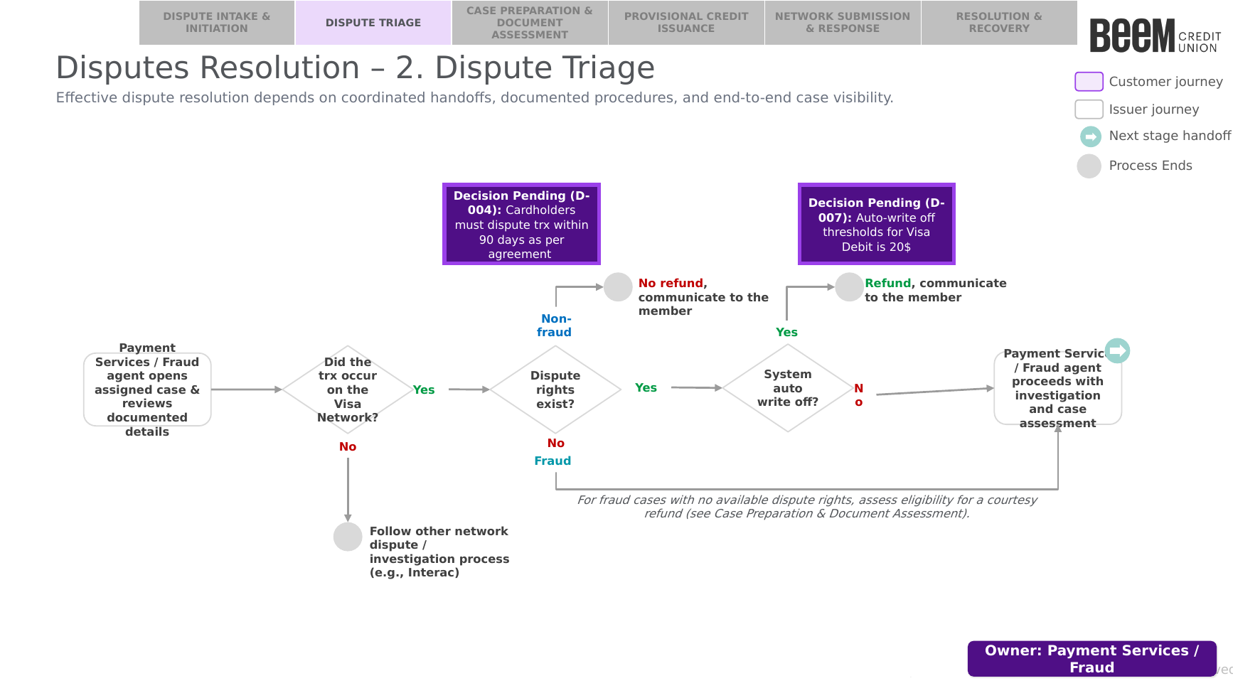

5.2 Procedure
The following procedure provides a step-by-step outline of the activities performed by the assigned Payment Services or Fraud agent as part of dispute triage.

5.2.1 Open Case and Confirm Network Eligibility
The Payment Services / Fraud agent should:
- Open the assigned case and review the documented details received from Growth.
- Confirm whether the disputed transaction occurred on the Visa Network.
- If the transaction did not occur on the Visa Network: the case should follow the applicable other network dispute / investigation process (e.g., Interac), and this procedure ends.
- If the transaction occurred on the Visa Network: proceed to Section 5.2.2 — Assess Dispute Rights.

5.2.2 Assess Dispute Rights
The Payment Services / Fraud agent should assess whether dispute rights exist for the transaction (e.g., filing window, dispute condition eligibility).
Decision Pending (D-004): Cardholders must dispute a transaction within 90 days, as per agreement.
- If dispute rights do not exist and the case is Non-Fraud: communicate to the member that no refund will be issued, and this procedure ends.
- If dispute rights do not exist and the case is Fraud: the Fraud Specialist should still proceed to Section 5.2.3 to assess eligibility for a courtesy refund to the victim of fraud (see Stage 3A — Case Preparation & Document Assessment).
- If dispute rights exist: proceed to Section 5.2.3 — Assess Auto Write-Off.

5.2.3 Assess Auto Write-Off and Proceed to Investigation
Where dispute rights exist, the Payment Services / Fraud agent should assess whether the dispute qualifies for a system auto write-off.
Decision Pending (D-007): The auto write-off threshold for Visa Debit is $20 CAD.
- If the dispute qualifies for auto write-off: communicate the refund to the member, and this procedure ends.
- If the dispute does not qualify for auto write-off (or is a fraud case being assessed for a courtesy refund): the Payment Services / Fraud agent proceeds with investigation and case assessment per Stage 3A — Case Preparation & Document Assessment.

Stage 3A: Case Preparation & Document Assessment (Payment Services / Fraud)

6.1 Process Flow
The visual overview below provides the end-to-end process for case preparation and document assessment. This stage runs in parallel with Stage 3B — Provisional Credit Issuance, and is owned by Payment Services / Fraud.
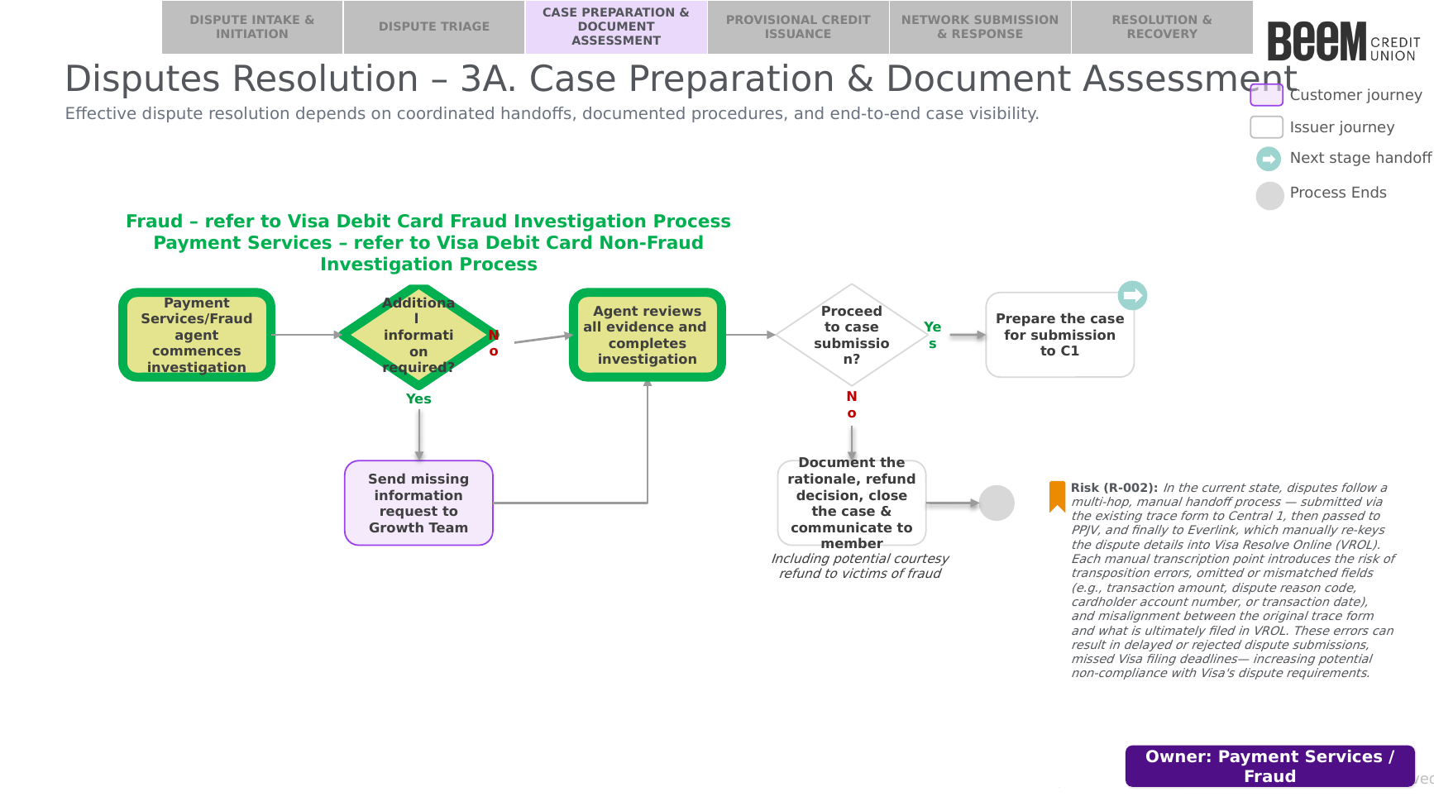

6.2 Procedure
The following procedure provides a step-by-step outline of the activities performed by the assigned Payment Services or Fraud agent as part of case preparation and document assessment.

6.2.1 Commence Investigation
Upon proceeding from Stage 2 — Dispute Triage, the assigned agent commences investigation of the case:
- Fraud: the Fraud Specialist should refer to the Visa Debit Card Fraud Investigation Process for the detailed investigation steps.
- Payment Services (Non-Fraud): the Payment Services agent should refer to the Visa Debit Card Non-Fraud Investigation Process for the detailed investigation steps.
Note: the detailed activities of gathering missing information and supporting evidence, and conducting and completing the investigation (including, for fraud cases, assessment of courtesy refund eligibility for victims of fraud), are performed in accordance with the applicable process referenced above and are out of scope for this procedure. This procedure resumes below once the agent has reviewed all evidence and completed the investigation.

6.2.2 Proceed to Case Submission
Once the agent has reviewed all evidence and completed the investigation per the applicable Fraud or Non-Fraud Investigation Process, the agent should determine whether to proceed to case submission.
- If yes: prepare the case for submission to Central 1 (C1), and proceed to Stage 4 — Network Submission & Response.
- If no: document the rationale and refund decision (including any courtesy refund issued to a victim of fraud), close the case, and communicate the outcome to the member. This procedure ends.
Risk (R-002): In the current state, disputes follow a multi-hop, manual handoff process — submitted via the existing trace form to Central 1, then passed to PPJV, and finally to Everlink, which manually re-keys the dispute details into Visa Resolve Online (VROL). Each manual transcription point introduces the risk of transposition errors, omitted or mismatched fields (e.g., transaction amount, dispute reason code, cardholder account number, or transaction date), and misalignment between the original trace form and what is ultimately filed in VROL. These errors can result in delayed or rejected dispute submissions and missed Visa filing deadlines, increasing potential non-compliance with Visa's dispute requirements.

Stage 3B: Provisional Credit Issuance (Finance) — Runs in Parallel with Stage 3A

7.1 Process Flow
The visual overview below provides the end-to-end process for provisional credit issuance. This stage runs in parallel with Stage 3A — Case Preparation & Document Assessment, and is owned by Finance.
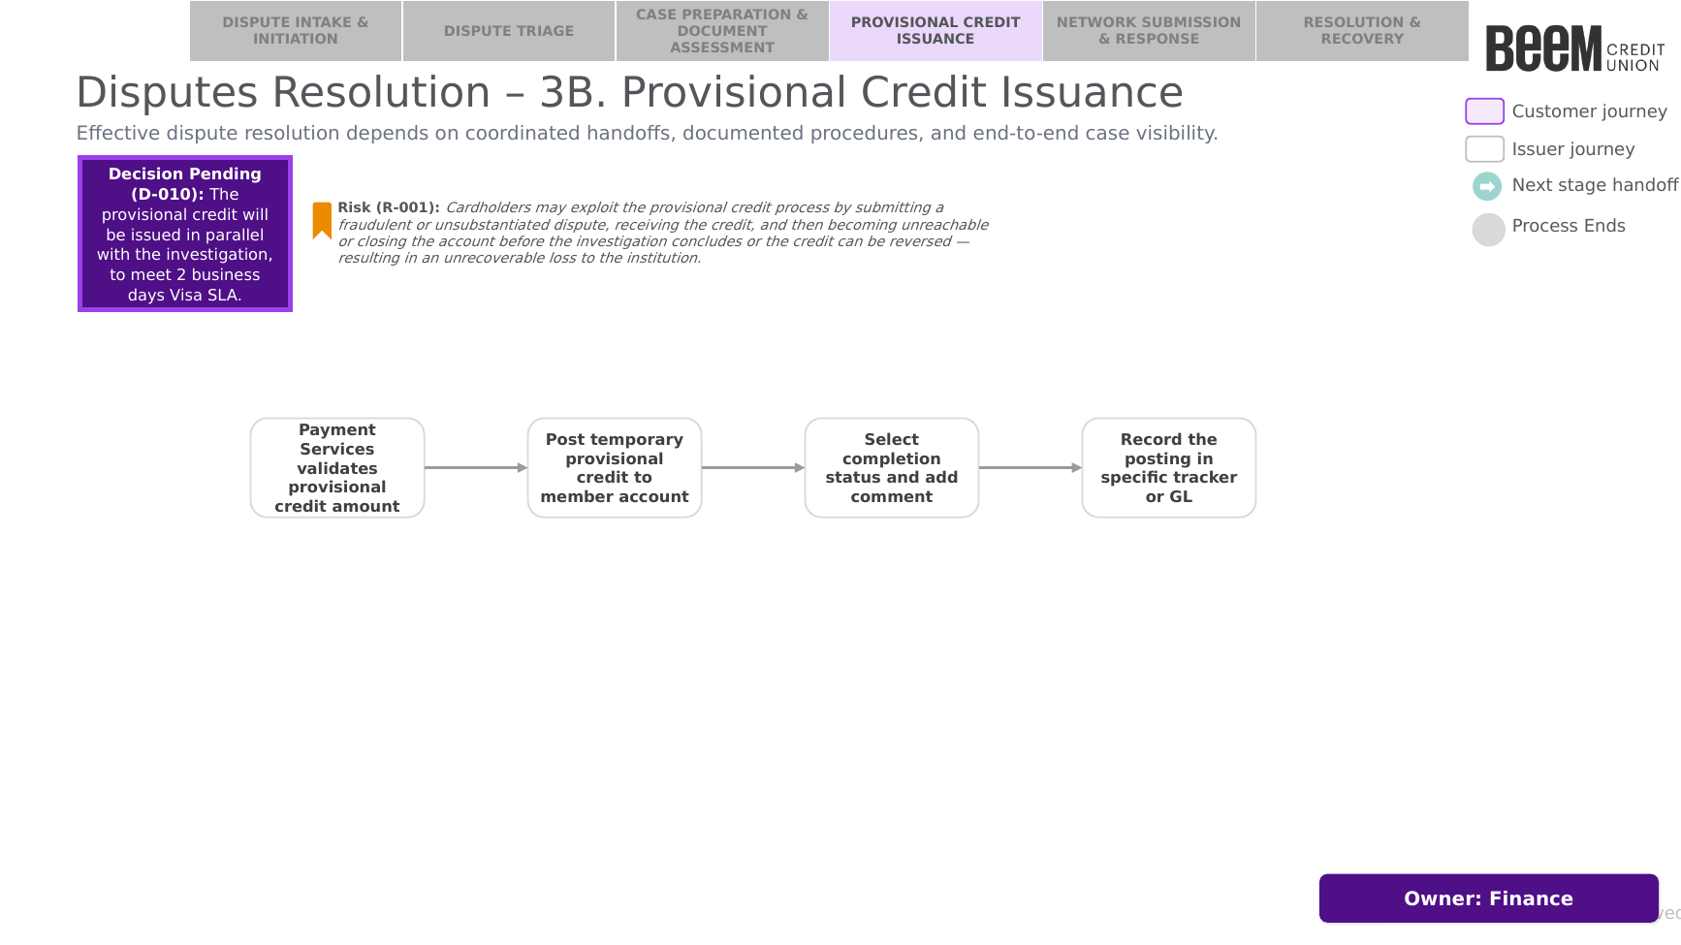

7.2 Procedure
Decision Pending (D-010): the provisional credit will be issued in parallel with the investigation, to meet the 2 business day Visa SLA.
The following procedure provides a step-by-step outline of the activities performed by Finance as part of provisional credit issuance.
- Validate the provisional credit amount and the member's account.
- Post the temporary provisional credit to the member's account within the applicable Visa SLA.
- Select the completion status in the case and add a comment.
- Record the posting in the applicable tracker or general ledger (GL).
Risk (R-001): Cardholders may exploit the provisional credit process by submitting a fraudulent or unsubstantiated dispute, receiving the credit, and then becoming unreachable or closing the account before the investigation concludes or the credit can be reversed — resulting in an unrecoverable loss to the institution.

Stage 4: Network Submission & Response (Payment Services / Fraud & Central 1)

8.1 Process Flow
The visual overview below provides the end-to-end process for submitting the dispute to the Visa network and managing the Acquirer response, pre-arbitration, and arbitration cycle. This stage is owned by Payment Services / Fraud.
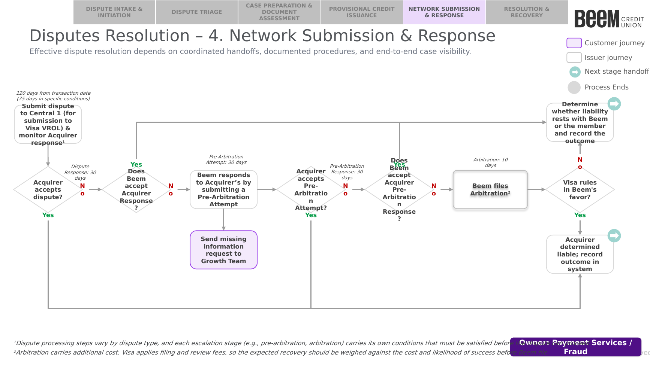

8.2 Procedure
Dispute processing steps vary by dispute type, and each escalation stage (e.g., pre-arbitration, arbitration) carries its own conditions that must be satisfied before the dispute can proceed. The chargeback request is submitted by Payment Services / Fraud to Central 1, which routes it, via PPJV, to the FIS Everlink Settlement team for submission to Visa via VROL. See the Visa Debit Program Chargeback User Guide for Everlink's defined program flow.

8.2.1 Submit the Dispute
The Payment Services / Fraud agent should:
- Submit the dispute to Central 1, for submission to Visa via VROL, within 120 calendar days from the transaction date (75 calendar days in the specific conditions set out in Appendix A).
- Monitor the Acquirer's response. The Acquirer has 30 calendar days from the dispute processing date to accept or decline the dispute.
- If the Acquirer accepts the dispute: proceed to Section 8.2.4 — Determine and Record the Outcome.
- If the Acquirer declines the dispute: proceed to Section 8.2.2 — Respond to the Acquirer's Response.

8.2.2 Respond to the Acquirer's Response
Where the Acquirer has declined the dispute, the Payment Services / Fraud agent should determine whether Beem accepts the Acquirer's response.
- If Beem accepts the Acquirer's response: proceed to Section 8.2.4 — Determine and Record the Outcome.
- If Beem does not accept the Acquirer's response: submit a Pre-Arbitration Attempt to the Acquirer within 30 calendar days from the processing date of the Acquirer's response. If additional information is required to support the attempt, send a missing information request to the Growth Team before submitting.
Where compelling evidence is submitted with the Pre-Arbitration Attempt, Beem must certify that the contact information provided does not match the cardholder's information on record, and that the cardholder has been contacted to review the evidence and provide an explanation as to why they continue to dispute the transaction.

8.2.3 Manage the Pre-Arbitration and Arbitration Cycle
The Payment Services / Fraud agent should monitor and respond to each stage of the pre-arbitration and arbitration cycle:
- Confirm whether the Acquirer accepts the Pre-Arbitration Attempt. If accepted, proceed to Section 8.2.4 — Determine and Record the Outcome.
- If the Acquirer does not accept the Pre-Arbitration Attempt, review the Acquirer's Pre-Arbitration Response (received within 30 calendar days of the Pre-Arbitration Attempt) and determine whether Beem accepts it. If accepted, proceed to Section 8.2.4 — Determine and Record the Outcome.
- If Beem does not accept the Acquirer's Pre-Arbitration Response, file for Arbitration within 10 calendar days from the processing date of the Pre-Arbitration Response. Note that Arbitration carries additional cost — Visa applies filing and review fees, so the expected recovery should be weighed against the cost and likelihood of success before Beem files.
- Confirm whether Visa rules in Beem's favour on Arbitration.
- If Visa rules in Beem's favour: the Acquirer is determined liable; record the outcome in the system and proceed to Stage 5 — Resolution & Recovery (Path 3: Acquirer Liable).
- If Visa does not rule in Beem's favour: proceed to Section 8.2.4 — Determine and Record the Outcome.
Note: to give FIS Everlink enough time to process the trace, a request to decline evidence received from the Acquirer (Dispute Response or Pre-Arbitration Response) must be submitted to Everlink within 10 business days of receipt of the proof, which is shorter than the 30-calendar-day Visa response window.

8.2.4 Determine and Record the Outcome
Where the Acquirer accepts the dispute or the Pre-Arbitration Attempt/Response, where Beem accepts the Acquirer's response or Pre-Arbitration Response, or where Visa does not rule in Beem's favour on Arbitration, the Payment Services / Fraud agent should determine whether liability rests with Beem (the Issuer) or the member, and record the outcome. Proceed to Stage 5 — Resolution & Recovery.

Stage 5: Resolution & Recovery (Payment Services / Fraud & Finance)

9.1 Process Flow
The visual overview below provides the end-to-end process for resolving and closing a dispute case following Stage 4 — Network Submission & Response. This stage is owned by Payment Services / Fraud and Finance.
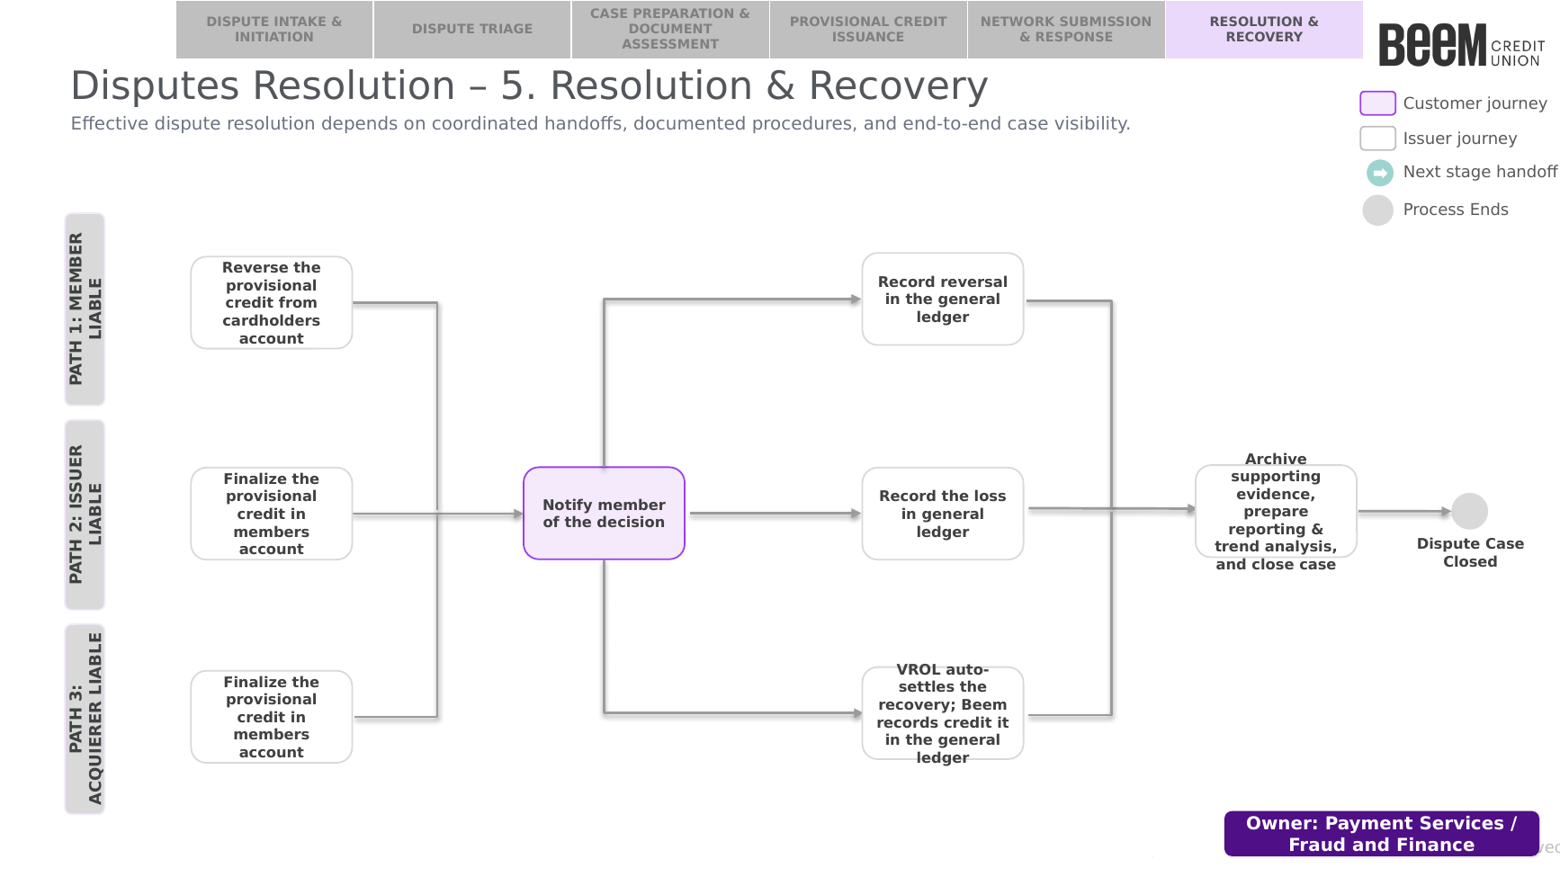

9.2 Procedure
The outcome of Stage 4 determines which of the following three paths applies. In all three paths, the Payment Services / Fraud agent should notify the member of the decision.

9.2.1 Path 1: Member Liable
Where the outcome determines the member is liable, Finance should:
- Reverse the provisional credit from the cardholder's account.
- Record the reversal in the general ledger.

9.2.2 Path 2: Issuer (Beem) Liable
Where the outcome determines Beem (the Issuer) is liable, Finance should:
- Finalize the provisional credit in the member's account.
- Record the loss in the general ledger.

9.2.3 Path 3: Acquirer Liable
Where the outcome determines the Acquirer is liable (i.e., Beem prevails), Finance should:
- Finalize the provisional credit in the member's account.
- Confirm VROL auto-settles the recovery; Beem records the credit in the general ledger.

9.2.4 Close the Case
Following completion of the applicable path above, the Payment Services / Fraud agent should:
- Archive the supporting evidence.
- Prepare reporting and trend analysis.
- Close the case. The dispute case is now closed.

Appendix

A. Visa Debit Dispute SLAs (Dispute Codes 10-13)
The table below summarizes the Visa Rules timeframes applicable to Dispute Codes 10 (Fraud) and 11 (Authorization), and Dispute Codes 12 (Processing Errors) and 13 (Consumer Disputes), referenced in Stage 4 — Network Submission & Response.
Step | Who (Dispute Code 10 & 11) | Who (Dispute Code 12 & 13) | Time Limit per Visa Rules
1. File the dispute | Issuer (Beem) | Issuer (Beem) | 120 days, or 75 days in some cases*
2. Dispute Response | N/A | Acquirer responds with evidence | 30 days
3. Pre-Arbitration attempt | Acquirer provides evidence | Issuer (Beem) pushes back | 30 days
4. Pre-Arbitration response | Issuer (Beem) pushes back | Acquirer responds | 30 days
5. Arbitration | Acquirer escalates to Visa | Issuer (Beem) escalates to Visa | 10 days
*75-day filing window — applies if any of the following conditions are met:
- Condition 11.1 — Card on the blocklist but the merchant accepted it anyway (Ref: Visa Rules 11.8.1)
- Condition 11.2 — Beem declined the transaction but the merchant processed it anyway (Ref: Visa Rules 11.8.2)
- Condition 11.3 — Merchant never requested authorization, or submitted the transaction too late (Ref: Visa Rules 11.8.3)
- Condition 12.7 — Merchant/Acquirer submitted invalid or non-compliant transaction data (Ref: Visa Rules 11.9.6)
- Condition 13.8 — An incoming Original Credit Transaction (OCT / push payment) was not accepted or posted (Ref: Visa Rules 11.10.8)
Issuers are limited to 35 disputes for a single cardholder PAN within the previous 120 calendar days; a submitted dispute beyond this threshold is invalid.

B. Reference Documents
The following documents are referenced throughout this procedure:
- Visa Debit Card Fraud Investigation Process
- Visa Debit Card Non-Fraud Investigation Process
- Fraud Intake Form Procedures
- Current Process — How to Initiate an ATM & POS Trace
- Visa Debit Program Chargeback User Guide

C. Open Items
The following items were raised during development of this procedure and are tracked for resolution:
ID | Type | Description
D-004 | Decision Pending | Cardholders must dispute a transaction within 90 days, as per agreement.
D-007 | Decision Pending | The auto write-off threshold for Visa Debit is $20 CAD.
D-010 | Decision Pending | The provisional credit will be issued in parallel with the investigation, to meet the 2 business day Visa SLA.
TBC-01 | Open Item | Reference document for member authentication procedures (Stage 1, Section 4.2.1) to be confirmed.
TBC-02 | Open Item | System used to locate the disputed transaction and confirm the network it occurred on (Stage 1, Sections 4.2.2 and 4.2.5) to be confirmed — believed to be DNA.
R-001 | Risk | Cardholders may exploit the provisional credit process by submitting a fraudulent or unsubstantiated dispute, receiving the credit, and then becoming unreachable or closing the account before the investigation concludes or the credit can be reversed — resulting in an unrecoverable loss to the institution.
R-002 | Risk | In the current state, disputes follow a multi-hop, manual handoff process — submitted via the existing trace form to Central 1, then passed to PPJV, and finally to Everlink, which manually re-keys the dispute details into Visa Resolve Online (VROL). Each manual transcription point introduces the risk of transposition errors, omitted or mismatched fields, and misalignment between the original trace form and what is ultimately filed in VROL, which can result in delayed or rejected dispute submissions and missed Visa filing deadlines.

Version History
DATE | VERSION | CHANGE
2 October 2026 | 001 | First Draft Initiated

